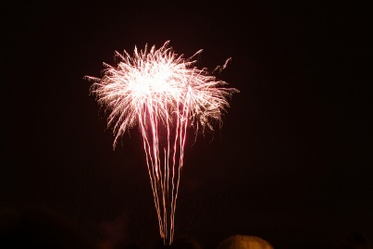
Brocade - A spider like effect in the sky like fine lace

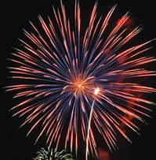
Bouquet Pattern - A bouquet patter is a floral-shaped aerial pattern of stars.

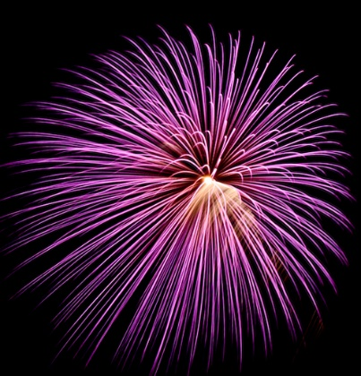
Chrysanthemum - A flower-like aerial pattern, usually resulting from a cake or mortar.
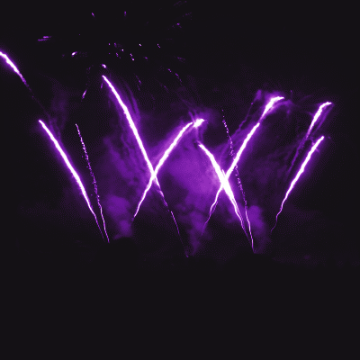
Comet - A type of star that leaves a long trail of sparks as it flies through the air.

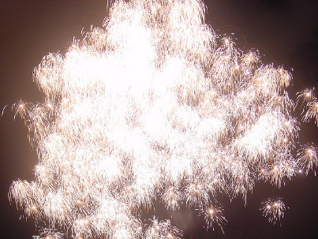
Crackle Effect - A fireworks effect that sounds like hundreds of crackles.

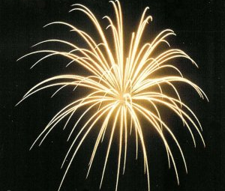
Dahlia - A shell that produces a starfish like shape.

Fish - An aerial effect that looks like a swarm of objects squirming though the air.

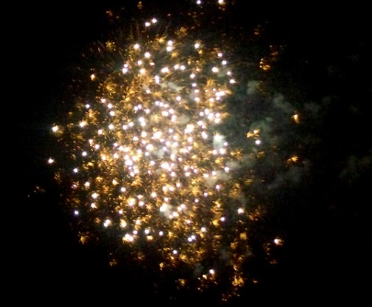
Glitter - A tail effect that contains flashes of light and small explosive bursts lasting several seconds.

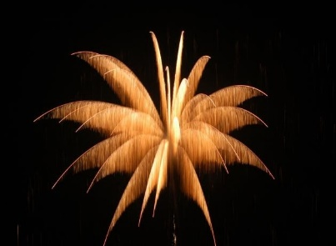
Palm Tree – A gold or silver rising tail followed by a gold or silver palm tree in the sky.

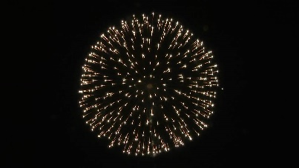
Peony - An aerial effect that looks like a spherical ball of colored lights in the sky.

Pistil – A small peony inside a larger peony. (See peony above

Spinner - A spinner is a type of star that spins in the sky and gives off large quantities of white light.

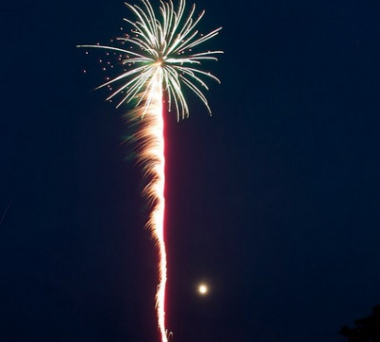
Tail - A trail that follows a star in the sky. Most comets, willows, and brocade effects have tails.
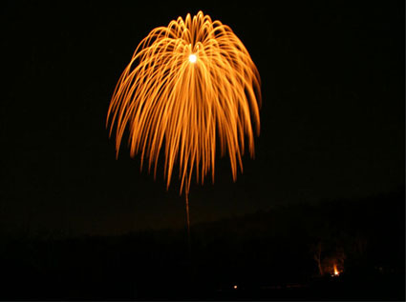
Willow - An aerial effect that looks like a giant gold willow tree in the sky trailing toward the ground before fading.

